**BRUTE FORCE ATTACKER**

**NAME : R. HARIKA**

**REG NO : 210421244046**

**DEPARTMENT : CSBS**

**PROJECT DOCUMENTATION**

**INTRODUCTION**

**ABSTRACT**

**SCOPE OF PROJECT**

**TYPES OF BRUTE FORCE ATTACK**

**TOOLS USED**

**STEPS TO PROTECT PASSWORDS**

**HOW USERS CAN STRENGTHEN PASSWORDS AGAINST BRUTE FORCE ATTACKS**

**HOW TO PREVENT BRUTE FORCE ATTACKS**

**PROGRAM WORKING ANALYSIS**

**OUTPUT OF REPORT**

**CONCLUSION**

**INTRODUCTION :**

In today's interconnected digital landscape, cybersecurity threats continue to evolve in complexity and sophistication, posing formidable challenges to organizations and individuals alike. Among the myriad of threats, brute force attacks stand out as a pervasive and insidious menace capable of compromising the integrity and confidentiality of sensitive information.

This project documentation aims to shed light on the phenomenon of brute force attacks, offering a comprehensive examination of their methodologies, impacts, and countermeasures. By understanding the intricacies of brute force attacks and implementing effective mitigation strategies, organizations can fortify their defenses and safeguard against potential breaches.

**ABSTRACT**

The documentation begins by providing an in-depth understanding of brute force attacks, including their definition, types, and common methodologies employed by attackers. It examines how brute force attacks exploit vulnerabilities in authentication mechanisms and encryption protocols to gain unauthorized access to sensitive information or compromise systems.

**SCOPE OF PROJECT REPORT**

**Methodologies and Techniques:** It will explore the various methodologies and techniques employed by attackers to execute brute force attacks, including password guessing, credential stuffing, and dictionary attacks. The report will delve into the technical intricacies of each method and highlight their implications for security.

**Impact Analysis:** The scope will encompass an in-depth analysis of the impact of brute force attacks on different sectors and industries, including financial services, healthcare, and e-commerce. Case studies and real-world examples will be examined to illustrate the consequences of successful brute force attacks.

**Vulnerability Assessment:** The report will conduct a vulnerability assessment to identify common weaknesses and vulnerabilities exploited by brute force attacks, such as weak passwords, lack of rate limiting, and inadequate authentication mechanisms.

**Mitigation Strategies:** It will provide a comprehensive overview of mitigation strategies and best practices to defend against brute force attacks. This includes technical controls such as multi-factor authentication, intrusion detection systems, and network segmentation, as well as user-centric measures such as security awareness training and password hygiene guidelines.

**Implementation Guidelines**: Practical implementation guidelines will be included to assist organizations in deploying and configuring effective security measures to mitigate the risks posed by brute force attacks. This may involve step-by-step instructions, configuration templates, and recommended tools or software solutions.

**Challenges and Limitations:** The report will address the challenges and limitations associated with mitigating brute force attacks, such as scalability issues, usability concerns, and the evolving nature of attack techniques. Strategies for overcoming these challenges will be discussed to provide a holistic understanding of the mitigation process.

**Future Trends and Recommendations:** Lastly, the scope will encompass an exploration of future trends and emerging technologies that may impact the landscape of brute force attacks. Recommendations for future research directions and proactive measures to stay ahead of evolving threats will be provided to guide organizations in maintaining robust security postures.

**TYPES OF BRUTE FORCE ATTACK :**

* Simple Brute Force Attacks
* Dictionary Attacks
* Hybrid Brute Force Attacks
* Reverse Brute Force Attacks
* Credential Stuffing

**TOOLS USED :**

Tools like these have workarounds programmed in them to:

* Work against many computer protocols (like FTP, MySQL, SMPT, and Telnet)
* Allow hackers to crack wireless modems.
* Identify weak passwords
* Decrypt passwords in encrypted storage.
* Run all possible combinations of characters.
* Operate dictionary attacks.

**STEPS TO PROTECT PASSWORDS**

**Use an advanced username and password :**

Protect yourself with credentials that are stronger than admin and password1234 to keep out these attackers. The stronger this combination is, the harder it will be for anyone to penetrate it.

**Remove any unused accounts with high-level permissions:**

These are the cyber equivalent of doors with weak locks that make breaking in easy. Unmaintained accounts are a vulnerability risks.

**Two-factor authentication (2FA):**

additionally, administrators can require two-step authentication and install an intrusion detection system that detects brute force attacks. This requires users to follow-up a login attempt with a second factor

**HOW USERS CAN STRENGTHEN PASSWORDS AGAINST BRUTE FORCE ATTACKS :**

**Stay away from frequently used passwords:**

It's important to avoid the most common passwords and to change them frequently.

**Use unique passwords for every site use:**

To avoid being a victim of credential stuffing, you should never reuse a password. If you want to take your security up a notch, use a different username for every site as well. You can keep other accounts from getting compromised if one of yours is breached.

**Use a password manager :**

Installing a password manager automates creating and keeping track of your online login info. These allow you to access all your accounts by first logging into the password manager. You can then create extremely long and complex passwords for all the sites you visit, store them safely, and you only have to remember the one primary password.

**HOW TO PREVENT BRUTE FORCE ATTACKS :**

The best way to prevent brute force attacks is to ensure that you have a strong password and protect it adequately.

Traditional guidance of combining letters, numbers and special characters has gone out of fashion in recent years, because it has made passwords harder to remember without being substantially more secure.

Instead, cyber security experts say that you can strengthen your passwords by making them longer. The more letters there are, the more potential combinations there are.

Use Captchas and Bot Detection: Integrate CAPTCHA (Completely Automated Public Turing test to tell Computers and Humans Apart) or bot detection mechanisms into login forms to differentiate between legitimate users and automated bots attempting brute force attacks.

**Use Captchas and Bot Detection:**

Integrate CAPTCHA (Completely Automated Public Turing test to tell Computers and Humans Apart) or bot detection mechanisms into login forms to differentiate between legitimate users and automated bots attempting brute force attacks.

**Regularly Update Software and Patch Vulnerabilities:**

Keep software and systems up-to-date with the latest security patches and updates. Vulnerabilities in software or operating systems can be exploited by attackers to launch brute force attacks or other types of cyber threats.

**Employ Web Application Firewalls (WAF):**

Deploy WAFs to protect web applications from common attack vectors, including brute force attacks. WAFs can inspect incoming traffic and block malicious requests before they reach the application server.

**PROGRAM WORKING ANALYSIS :**

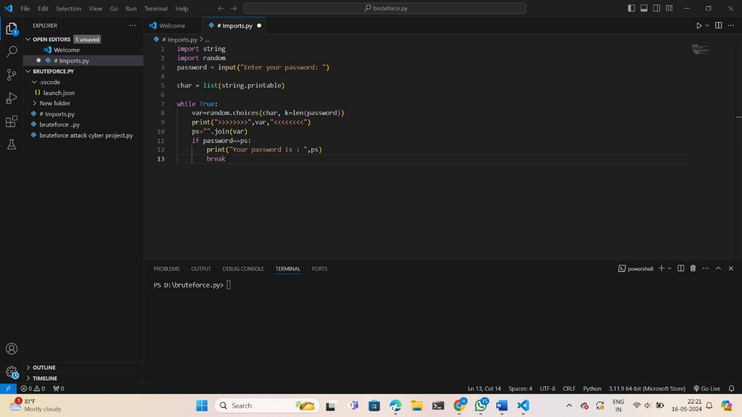

Overall, the script appears to generate a random password of the same length as the user-input password and checks if the generated password matches the input password. If they match, it prints the generated password.

In these the versatility, ease of development, rich ecosystem, and community support make Python a compelling choice for projects focused on preventing brute force attacks and enhancing cybersecurity defenses. Its combination of simplicity, power, and flexibility enables developers to create robust, effective solutions that address the complex challenges posed by modern cyber threats.

**OUTPUT OF REPORT :**

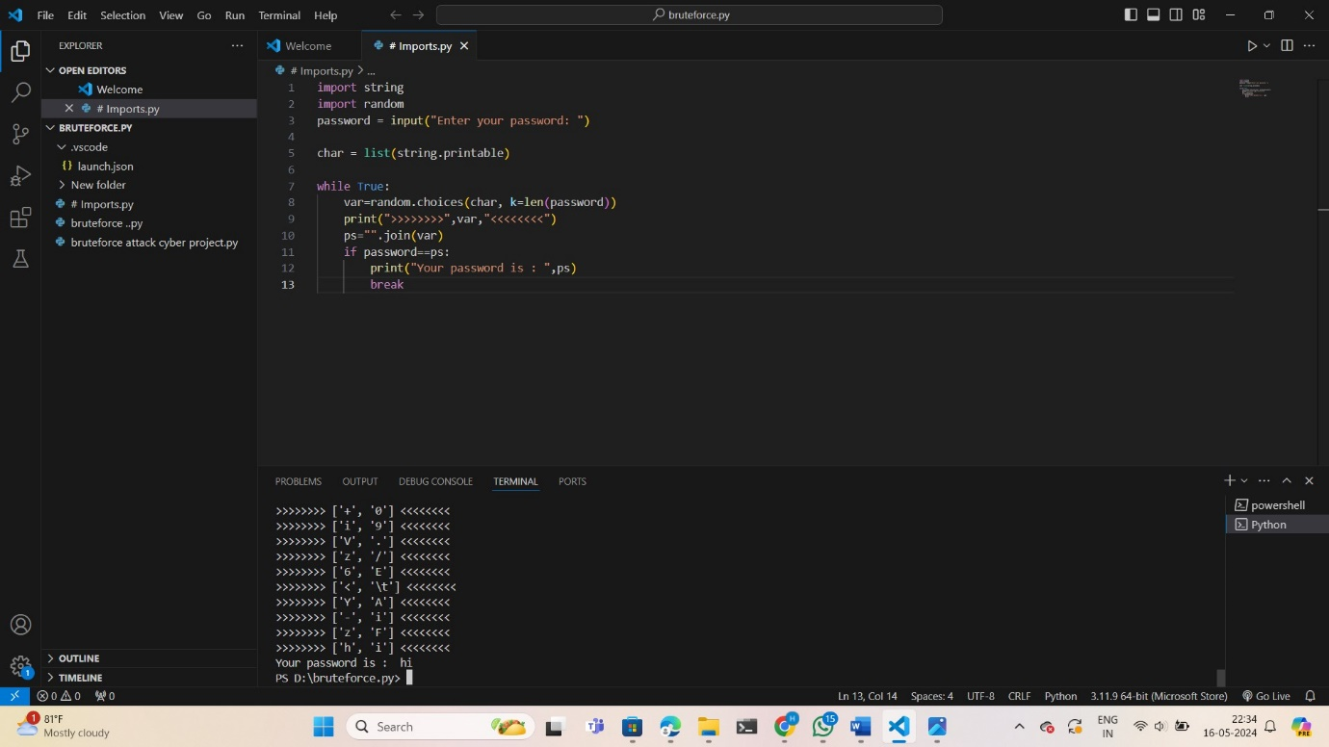

**CONCLUSION :**

In conclusion, the project documentation on brute force attacks provides valuable insights into the nature of this pervasive cybersecurity threat and effective strategies for mitigating its risks. Throughout the documentation, we have explored the methodologies, impacts, and implications of brute force attacks on various systems and industries.